**The 27th China Hi-Tech Fair**

**Awards Selection Activity Guidelines**

To promote technological innovation among enterprises, stimulate the potential of talents and research teams, and encourage exhibitors at the Chin Hi-Tech Fair (hereinafter referred to as "CHTF") to demonstrate their technological innovation capabilities, the 27th CHTF will organize an awards selection activity. The specific plan is as follows:

**I. Activity Name**

Awards Selection for the 27th China Hi-Tech Fair

### **II. Award Categories** The awards for 2025 CHTF selection activity include the following categories:

### (1) Outstanding Organization Award

### (2) Outstanding Scientific Research Achievement Innovation Award

### (3) Outstanding Exhibition Award

### (4) Outstanding Technological Innovation Enterprise Award

### (5) Outstanding Partner Contribution Award

### **III. Award Details**

#### **(1) Organizing Body**

The awards selection work is organized by the Office of the Organizing Committee of the China Hi-Tech Fair (hereinafter referred to as the "Organizing Committee Office").

#### **(2) Eligibility**

#### Exhibiting enterprises and partners of the 27th CHTF.

#### **(3) Requirements**

1). Each participating enterprise may apply for multiple award categories. Enterprises must submit application materials to be eligible for selection.

2). Participating products must not involve any intellectual property disputes or controversies. The organizer will closely collaborate with intellectual property protection agencies. If any infringement or suspected infringement is authoritatively confirmed, the awards received by the relevant products will be promptly revoked.

#### **(4) Selection Method**

The CHTF Organizing Committee will hold a centralized review meeting to evaluate the applications based on the submitted materials and determine the list of winners according to the final results.

#### **(5) Award Design**

* ****Outstanding Organization Award****

1. Eligibility: All group organizers of CHTF, such as provincial/municipal/district delegations, agencies, and relevant cooperative associations.
2. Selection Method: Enterprise application and comprehensive evaluation by the Organizing Committee.
3. Award Ceremony: Presented at the on-site activity area.
4. Award Time: Morning of November 15th (subject to the actual on-site schedule).

* ****Outstanding Scientific Research Achievement Innovation Award****

1. Eligibility: All universities and research institutions participating in CHTF as groups. Exhibits must be submitted as sets/units; physical exhibits or models must be displayed on-site, with independent innovation accounting for no less than 50% of the exhibit.
2. Selection Method: Enterprise application and comprehensive evaluation by the Organizing Committee.
3. Award Ceremony: Presented at the on-site activity area.
4. Award Time: Afternoon of November 15th (subject to the actual on-site schedule).

* ****Outstanding Exhibition Award****

1. Eligibility: All exhibitors and groups with specially decorated booths of 36 square meters or larger at CHTF, with physical products displayed on-site.
2. Selection Method: Enterprise application and comprehensive evaluation by the Organizing Committee.
3. Award Ceremony: Winners shall collect the award at the exhibitor registration desk.
4. Award Time: All day on November 11th and 12th.

* ****Outstanding Technological Innovation Enterprise Award****

1. Eligibility: All exhibitors at CHTF that have received national or provincial/ministerial-level scientific and technological awards, or possess two or more independently certified core technologies and patents.
2. Selection Method: Enterprise application and comprehensive evaluation by the Organizing Committee.
3. Award Ceremony: Winners shall collect the award at the exhibitor registration desk.
4. Award Time: All day on November 11 and 12.

* ****Outstanding Partner Contribution Award****

1. Eligibility: All third-party partners of CHTF, such as construction contractors, sponsors, exhibition venues, business travel services, host contractors, logistics providers, etc.
2. Selection Method: Enterprise application and comprehensive evaluation by the Organizing Committee.
3. Award Ceremony: Winners shall collect the award at the exhibitor registration desk.
4. Award Time: To be specified.

**(6) Participation Method and Fee Payment Instructions**

1). Participation Fee: The fee for participating in any award category is RMB 500 per participating unit (the fee is charged per unit, regardless of the number of awards applied for).

2). Applicants must complete the online application on the CHTF official website [www.chtf.com](http://www.chtf.com/" \t "https://chat.deepseek.com/a/chat/s/_blank) under the "Awards Selection Activity" section by 17:00 Beijing Time on October 10, 2025, or scan the corresponding QR code below to apply.

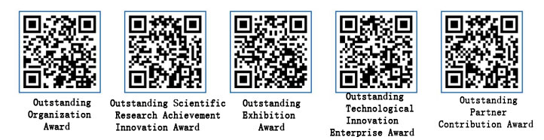

Application Steps:  
(1) Scan the corresponding award QR code and fill in the "Basic Application Information" online.  
(2) Download the "Award Application Form" template and complete it.  
(3) Upload the signed/stamped scanned PDF version of the application form for the applied category and the compressed file of relevant supporting materials.  
(4) Click "Submit" to complete the application.  
(5) Complete the online payment according to the activity guidelines and payment instructions.  
Note: Only one application category can be submitted at a time. For multiple award categories, submit them separately in the system.

1. Payment Instructions and Invoice Issuance:

* Payment Instructions:

(1) Bank Transfer: If paying via bank transfer, please note "Award Fee" in the remarks.

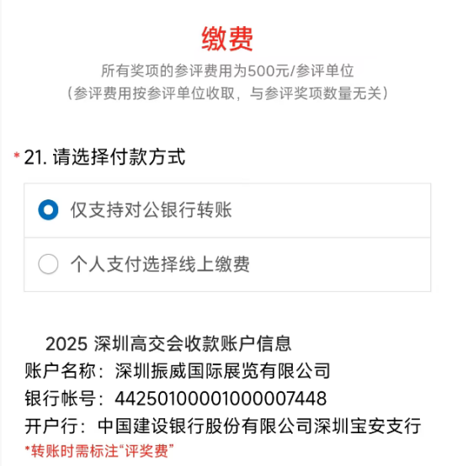(2) WeChat Pay: If paying via WeChat, please indicate the company’s authorization for individual payment, including the authorized payer’s name and mobile number. Be sure to upload a screenshot of the WeChat payment confirmation.

* 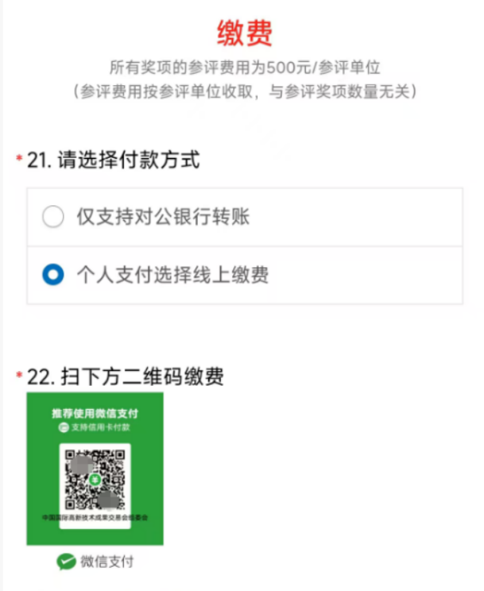Invoice Issuance: Electronic VAT ordinary invoices will be issued uniformly by Shenzhen Zhenwei International Exhibition Co., Ltd. and sent via email.

### **IV. Benefits for Winners**

****(1) Award Ceremony:**** Some awards will have dedicated ceremony sessions, inviting relevant leaders and guests to present the awards.  
****(2) Offline Display:**** During CHTF, award-winning products will be featured in thematic displays to attract global buyers and facilitate targeted engagement between buyers and winning enterprises.  
****(3) Online Display:**** The CHTF official website will establish an online display section, showcasing award-winning products from previous years year-round. Award labels will be highlighted in the exhibitor and product sections, with priority search rankings and smart targeted traffic.  
****(4) Award Publications:**** Winners will receive trophies and certificates. A yearbook of award-winning products will be produced and distributed to important global business groups, group buyers, and VIP buyers.  
****(5) Official Promotion:**** Award-winning products, enterprises, and groups will be promoted through CHTF’s official channels.  
****(6) Media Coverage:**** Comprehensive on-site interviews, live interactions, and authoritative reports will be conducted through nine major media clusters. Promotion services will also be provided via various social media platforms.  
****(7) Roadshows and New Product Promotion:**** Winning enterprises or groups may receive discounts on venue fees for on-site roadshows or new product promotions.

### **V. Selection Process and Timeline**

All self-nominated awards at CHTF will be selected through a evaluation system managed by the CHTF Organizing Committee Office, with participation from relevant units. The specific process is as follows:

****(1) Self-Nomination****  
Enterprises or groups shall complete the online "Award Application Form" according to the instructions and upload relevant supporting materials (if applicable). After submission, complete the online payment.  
Deadline: October 10, 2025, 17:00.

****(2) Material Review****  
The CHTF Organizing Committee Office will review the application materials and payment status.  
Review Period: October 10–20, 2025.

****(3) Evaluation****  
The Organizing Committee Office will conduct on-site evaluations and determine the list of winners.  
Deadline: October 20–30, 2025.

****(4) Public Announcement****  
The list of winners will be publicly announced for a period of 5 working days. Any issues raised during the announcement period will be investigated and verified by the Organizing Committee Office in collaboration with relevant units, and review opinions will be formed.

****(5) Recognition****  
The Organizing Committee will officially announce the results on its website after the announcement period and arrange online and offline displays for award-winning products, enterprises, or groups.  
Award Announcement: November 3, 2025.

****(6) Award Distribution and Collection****  
The Organizing Committee will categorize the awards by field. Some awards will be presented at on-site ceremonies, with government leaders invited as guests to present trophies and certificates. Other awards can be collected by winners at the exhibitor registration desk.  
Award Ceremony Dates: November 14–15, 2025.  
Collection Dates: November 11–12, 2025.

### **VI. Other Matters**

(1) Supporting materials must be uploaded and submitted as a compressed file, named "Award Category + Company Name."  
(2) Enterprises involved in major or above production safety accidents, environmental pollution incidents, serious violations of tax or statistics laws, or whose legal representatives are involved in major illegal or disciplinary cases within the year will be disqualified. Individuals involved in criminal activities or academic fraud will also be disqualified.  
(3) Once submitted, the Organizing Committee reserves the right to use the provided materials and images without further notice and ensures that the information will not be disclosed to unrelated third parties.

****Organizing Committee of China Hi-Tech Fair****  
Contact: Ms. Ding  
Phone: 153 6100 2645  
Email: [1648848957@qq.com](https://mailto:1648848957@qq.com/" \t "https://chat.deepseek.com/a/chat/s/_blank)

Contact: Mr. Lin  
Phone: 153 3871 9495  
Email: [2285959170@qq.com](https://mailto:2285959170@qq.com/" \t "https://chat.deepseek.com/a/chat/s/_blank)